Stupska bb, 71000 Sarajevo / Tel. +387 61 162 592 +387 62 324 495/ www.e
-
ventexpo.com /

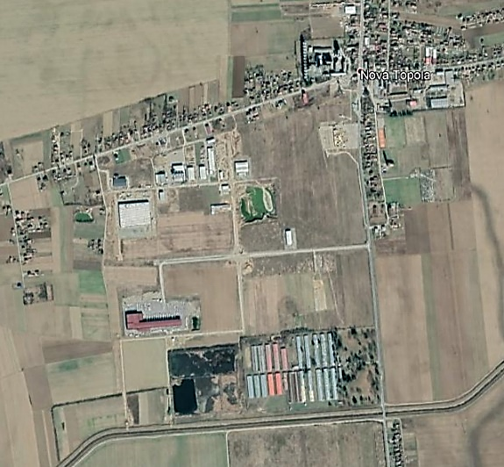
Project title | Initiating a new investment cycle in the Agroindustrial zone Nova Topola
Sector | Locations are suitable for agri-cultural and food industry, metal-processing, and wood-processing industry, leather and footwear industry, services, trading centers, technical and engineering services, etc.
Location | The City of Gradiška
Location description | Agroindustrial Zone Nova Topola is an extremely attractive greenfield location for investment, located in the vicinity of key roads, leaning on the regional road Gradiška - Banja Luka, 7 km from the Gradiška-Banja Luka Highway, 10 km away from the city center and border crossing, 24 km away from the airport in Banja Luka.
Company description | Type of the zone: Greenfield, industrial-business.  Surface: 135 ha.  Available parcels: Currently available 70 parcels intended for sale to investors. The largest parcel is 41,079 m², and the smallest is 1,693 m².  Infrastructure: The Zone is equipped with utility infrastructure: water, utility, electricity, telephone/internet. Roads within the Zone are under construction.  Ownership: 100% City of Gradiška.  Investment opporunities: Purchase, lease.  Price of land sale: from BAM 1 to 80/m².  Lease fee: from BAM 12 to 24/m².  Compensation for regulation of construction land: free of charge.  Procedure and conditions for entry into the Zone: Land auction, conclusion of a purchase and sale contract and entry into possession.
Project status | The project is in progress.
Project description | The Zone is equipped with modern electro-network, road, water supply, sewerage and ICT infrastructure. The area of individual parcels ranges from 1,693 m² to 41,079 m², with a possibility to merge the parcels into parcels of larger area. The Agroindustrial Zone Nova Topola is focused on both, foreign and domestic investors engaged in various sectors (agri-cultural and food-processing industry, metal-processing, and wood-processing industry, leather and footwear industry, services, trading centers, technical and engineering services, etc.).  The project goal is to attract investors in the field of production and supporting industries, and to create new jobs.
Estimated total investment cost | Total investment in the infrastructure of the Agroindustrial Zone Nova Topola so far has been EUR 5,901,191.32, which includes investments into utility and traffic infrastructure, electro-network, waste water treatment plant, i.e. creating all necessary preconditions for investments.
Inputs provided by local partner | Value |  | Description
Inputs provided by the City of Gradiška:
- The Zone is equipped with utility infrastructure;
- The Zone is 100% in the ownership of the City of Gradiška;
- Spatial-urban development plan of the local self-government available;
- Land property resolved;
- Tax incentives.
Inputs required from foreign partner |  | Value | Description
 | Depend on the type of business activities the investor aims to start.  Price of land sale: from BAM 1 to 80/m².  Compensation for regulation of construction land: free of charge. |  | - Land purchase  - Construction of production plant  - Performing business activities
Form of cooperation with foreign partner |  | Financial | Technical
 | Financial form of cooperation with foreign partner depends on the type of production the investor plans to activate. |  | Technical form of cooperation with foreign partner depends on the type of production the investor plans to activate.
Supporting information available | For additional information about this project, please contact either by e-mail:  info@e-ventexpo.com or phone number: +387 61 162 591

