Stupska bb, 71000 Sarajevo / Tel. +387 61 162 592 +387 62 324 495/ www.e
-
ventexpo.com /

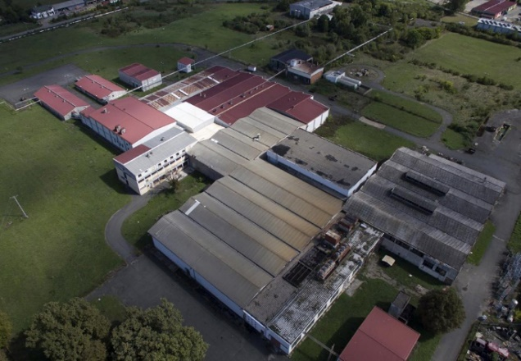
Project title | Brownfield project - Use of the existing facility of "AGROEXPORT COMPANY", to start new business activities
Sector | Food industry
Location | 16. krajiške brigade bb, Gradiška
Location description | The facility is located in the industrial zone next to the former Customs Terminal in Gradiška. It is 500 m away from the border crossing from BiH to the Republic of Croatia, and is 5 km away from the Zagreb-Belgrade Highway.
Company description | The subject of the investment is a brownfield site which is 100% in the private ownership of the company "AGROEXPORT KOMPANI".  The City of Gradiška offers brownfield sites as potential locations for successful investment and business. Proactive and flexible city administration is at the service of potential investors (all necessary permits are issued in record time.)  The fertile arable land of Lijevče Field, a longlasting tradition of agricultural production, excellent climate conditions and constructed agricultural infrastructure, represent the main resource and potential for the development of this sector.  Gradiška is the largest fruit producer, with the production of over 50,000 tons per year, and it is one of the largest vegetable producers in Bosnia and Herzegovina. Large quantities of fruits and vegetables with a long tradition of production create preconditions for branding local products.  In the land structure of the city of Gradiška, agricultural land occupies 66%, which is over 50,000 ha. Preserved and unpolluted natural resources of Gradiška are ideal for investment in food production in the organic concept, and there is a great potential for the production of first-class fruit in large quantities, investment in plantations, cold-storages, processing plants and drying rooms.  In the city of Gradiška, there are already significant business entities in the field of food industry, which use the most modern technical and technological achievements in their production processes, especially in the production of animal feed, bakery products and meat processing. One of the biggest disadvantages of the economy of the city of Gradiška in the field of food industry is the lack of processing capacities for processing fruits and vegetables.  In addition to the potentials that Gradiška offers in the production of fruits and vegetables, the existence of such processing capacity would greatly encourage the growth and development of this sector.
Project status | - Concept  - The process of finding a strategic partner is in progress.
Project description | The project includes the restoration and modernization of existing facilities, as well as investment in the production facilities.  The aim of the project is use of the existing facility of "AGROEXPORT COMPANY", according to the investor’s needs and requirements.
Estimated total investment cost | The total investment cost will be determined depending on the investor’s needs and requirements.
Inputs provided by local partner | Value |  | Description
Existing facilities and infrastructure

Surface area of the facilities is 15,968 m²; year of construction is 1970-1990.
Construction type: classic brick+skeletal structure.
The necessary permits for construction are issued by the District Commercial Court in Banja Luka. Urban Development Consent for Works and Construction Permit are issued by the City of Gradiška.
Investment opportunities offered by the owner are: purchase and lease.
Inputs required from foreign partner |  | Value | Description
 |  |  | Rehabilitation and modernization of facilities, modernization of production facilities, commencement of production and employment of qualified staff from the territory of the city of Gradiška.
Form of cooperation with foreign partner |  | Financial | Technical
 | Concession or sale |  | Management expertise
Supporting information available | For additional information about this project, please contact either by e-mail:  info@e-ventexpo.com or phone number: +387 61 162 591

