Stupska bb, 71000 Sarajevo / Tel. +387 61 162 592 +387 62 324 495/ www.e
-
ventexpo.com /

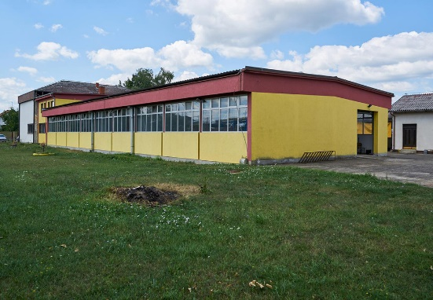
Project title | Brownfield project - Use of the existing facility of "TWINS PROM" Gradiška, previously used for production of food products, to start new business activities
Sector | Food industry, with the possibility of changing the type of production
Location | Gradiška, Banjalučka 5
Location description | The facility is located along the Gradiška– Banja Luka regional road, in the vicinity of the former Customs Terminal BiH – Croatia, which is only 1 km away. The facility is 5 km away from the Zagreb – Belgrade and Gradiška – Banjaluka Highway.
Company description | The subject of the investment is a brownfield site which is 100% in the private ownership of the company "TWINS PROM", whose business activity has been the production of biscuits.  The City of Gradiška offers brownfield sites as potential locations for successful investment and business. Proactive and flexible city administration is at the service of potential investors (all necessary permits are issued in record time.)  The fertile arable land of Lijevče Field, a longlasting tradition of agricultural production, excellent climate conditions, constructed agricultural infrastructure, represent the main resource and potential for the development of this sector.  Gradiška is the largest fruit producer, with the production of over 50,000 tons per year, and it is one of the largest vegetable producers in Bosnia and Herzegovina. Large quantities of fruits and vegetables with a long tradition of production represent favorable preconditions for branding local products.  In the land structure of the city of Gradiška, agricultural land occupies 66%, which is over 50,000 ha. Preserved and unpolluted natural resources of Gradiška are ideal for investment in food production in the organic concept, and there is a great potential for the production of first-class fruit in large quantities, investment in plantations, cold-storages, processing plants and drying rooms.  In the city of Gradiška, there are already significant business entities in the field of food industry which use the most modern technical and technological achievements in their production processes, especially in the production of animal feed, bakery products and meat processing. One of the biggest shortcomings of the economy of the city of Gradiška in the field of food industry is the lack of processing capacities for processing fruits and vegetables.  In addition to the potentials that Gradiška offers in the production of fruits and vegetables, the existence of such processing capacity would greatly encourage the growth and development of this sector.
Project status | - Concept  - The process of finding a strategic partner is in progress.
Project description | Exceptional geostrategic position, developed traffic infrastructure, vicinity of the border crossing, availability of raw materials and other factors of production are guarantees of successful business in the implementation of this project.  The aim of the project is use of the existing facility of "TWINS PROM", according to the investor’s needs and requirements.
Estimated total investment cost | The total investment cost will be determined depending on the investor’s needs and requirements.
Inputs provided by local partner | Value |  | Description
Available existing building of 14x45.2 m², divided into three equal parts. The parcel the facility is located on has the surface area of 0.5 ha, and in the vicinity of the facility there are supporting facilities, and a large parking lot. Available utility infrastructure: electric power, water supply, hydrant network, sanitation network, telephone, lighting and lightning installation.
The necessary permits for construction are issued by the District Commercial Court in Banja Luka. The Urban Development Consent for Works and Construction Permit are issued by the City of Gradiška.
Inputs required from foreign partner |  | Value | Description
 |  |  | Establishing the production process through investment in fixed assets and employment of staff from the territory of the city of Gradiška.
Form of cooperation with foreign partner |  | Financial | Technical
 | Concession |  | Management expertise
Supporting information available | For additional information about this project, please contact either by e-mail:  info@e-ventexpo.com or phone number: +387 61 162 591

