Stupska bb, 71000 Sarajevo / Tel. +387 61 162 592 +387 62 324 495/ www.e
-
ventexpo.com /

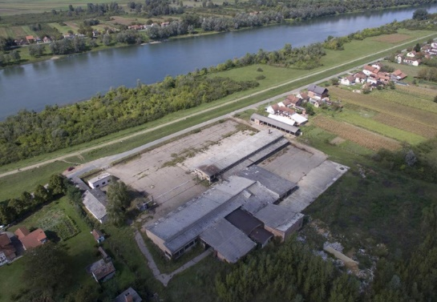
Project title | Brownfield project - Use of the existing facility of "CIGLANA" a.d. Gradiška, previously used for processing industry or storage, to start new business activities
Sector | Traffic and storage, construction material industry, processing industry, etc.
Location | Bok Jankovac bb, Gradiška
Location description | The facilities are located along the river bank of the Sava River, 2 km away from the border crossing from BiH to Croatia, and 1 km from the former Customs Terminal, on a local road connecting Gradiška with the Municipality of Srbac. The facility is 6 km away from the Belgrade – Zagreb Highway and 10 km away from the Gradiška – Banja Luka Highway.
Company description | The subject of the investment is a brownfield site which is 100% in the private ownership of Ninković Nenad.  The City of Gradiška offers brownfield sites as potential locations for successful investment and business. Proactive and flexible city administration is at the service of potential investors (all necessary permits are issued in record time.)  Area of the city of Gradiška is extremely attractive for opening business operations and branch offices, first of all for companies which want to operate outside of the EU’s legal framework, and export to the countries which are members of the Union, as well as for business entities that want to run their business in the framework of the markets which belong to the CEFTA agreement.  Exceptional geostrategic position, developed traffic infrastructure, developed economy, vicinity of the border crossing, availability of raw materials and other production factors are guarantees of successful business in the implementation of this project.
Project status | - Concept  - The process of finding a strategic partner is in progress.
Project description | The project includes the restoration, rehabilitation and modernization of the existing facility, as well as investment in the production capacity.  The aim of the project is use of the existing facility of "CIGLANA" a.d. Gradiška according to the investor’s needs and requirements.
Estimated total investment cost | The total investment cost will be determined depending on the investor’s needs and requirements.
Inputs provided by local partner | Value |  | Description
Existing facilities and infrastructure

Surface area of the facility is 4,100 m², year of construction: 1960. Construction type: small bricks. Available utility infrastructure: water supply, electric power (power substation 500 kWA, sanitation network at the distance of 35 m from the factory.
The necessary permits for construction are issued by the District Commercial Court in Banja Luka. The Urban Development Consent for Works and the Construction Permit are issued by the City of Gradiška.
Investment opportunities: purchase or lease.
Inputs required from foreign partner |  | Value | Description
 |  |  | Reconstruction of the facility, commencement of production activities, employment of professional and qualified staff from the city of Gradiška.
Form of cooperation with foreign partner |  | Financial | Technical
 | Concession or sale |  | Management expertise
Supporting information available | For additional information about this project, please contact either by e-mail:  info@e-ventexpo.com or phone number: +387 61 162 591

