Stupska bb, 71000 Sarajevo / Tel. +387 61 162 592 +387 62 324 495/ www.e
-
ventexpo.com /

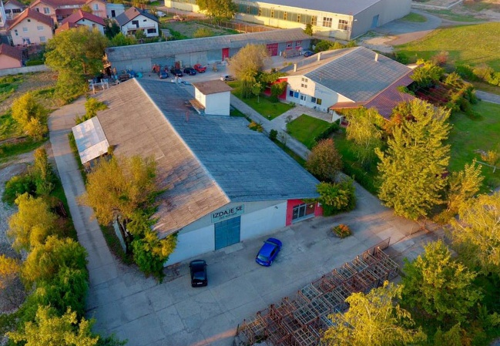
Project title | Brownfield project - Use of the existing facility of "GAMATEKS" a.d. Gradiška, previously used for production of textiles, to start new business activities
Sector | Textile industry, with the possibility of changing business activities
Location | Gradiška
Location description | The facility is located along the transit road leading from Gradiška to Kozarska Dubica. It is 1 km away from the border crossing from BiH to Croatia, 3 km away from the Banja Luka – Gradiška Highway, and 5 km away from the Zagreb-Belgrade Highway.
Company description | The subject of the investment is a brownfield site which is 100% privately owned by the company "Gamateks", whose business activity has been textile production.  The City of Gradiška offers brownfield sites as potential locations for successful investment and business. Proactive and flexible city administration is at the service of potential investors (all necessary permits are issued in record time).  Regarding textile industry, the city of Gradiška has a long tradition and a good international reputation. The structure of products is very wide: heavy clothing – for both, men and women, light clothing, sports equipment, underwear, protective equipment, medical program, cooking program, etc. Experienced and qualified workforce, vicinity of the markets of Western Europe, short delivery time to European traders, long tradition and know-how - all these are potentials that attract international companies and investors. Over 90% of existing companies are export-oriented, out of which the most important are: "ELLA TEXTILE" d.o.o. (Calzedonia Group), Gončin d.o.o. which produces protective equipment and medical clothing for well-known Austrian customers, Hakadesch d.o.o. which produces a lingerie program for a well-known German customer, Svetislav Tex d.o.o. which produces most of its clothing for the Italian market, as well as Botex d.o.o., Mardi d.o.o. and many others. It has to be mentioned that companies from Gradiška in the textile industry cooperate with the world's leading brands such as: C&A, Burberry, Piere Cardin and others.
Project status | - Concept  - The process of finding a strategic partner is in progress.
Project description | The project involves the rehabilitation and modernization of the production plant formerly used for the production of textile.  The aim of the project is use of the existing facility of "GAMATEKS" a.d. Gradiška, according to the investor’s needs and requirements.
Estimated total investment cost | The total investment cost will be determined depending on the investor’s needs and requirements.
Inputs provided by local partner | Value |  | Description
 |  |  | There is an existing building of 550 m² + loft (warehousing space of surface area of about 250 m2). It has a separate gate, access road for trucks, toilet, mini kitchen, three offices and a reception area. Gas based heating. All the necessary infrastructure is present in and around the building: power supply, water supply network, sanitation network, telecommunications, lighting, access roads.
Inputs required from foreign partner |  | Value | Description
 |  |  | Investing in machine tools for textile production, employment of professional staff from the area of the city of Gradiška
Form of cooperation with foreign partner |  | Financial | Technical
 | Concession |  | Management expertise
Supporting information available | For additional information about this project, please contact either by e-mail:  info@e-ventexpo.com or phone number: +387 61 162 591

