Stupska bb, 71000 Sarajevo / Tel. +387 61 162 592 +387 62 324 495/ www.e
-
ventexpo.com /

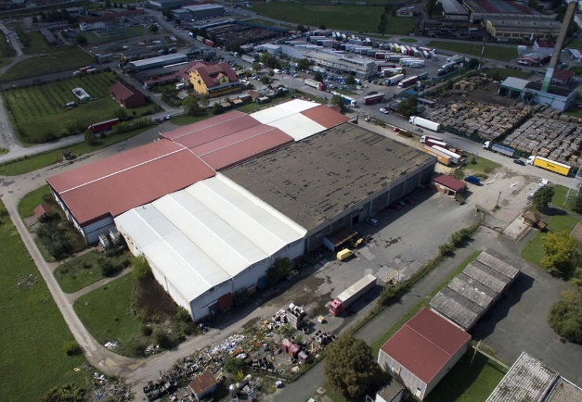
Project title | Brownfield project - Use of the existing facility "MILKA AGRO", previously used for the food industry and storage, to start new business activities
Sector | Warehousing of fruit and vegetables
Location | 16. krajiške brigade bb, Gradiška
Location description | The facility is located in the industrial zone next to the former Customs Terminal in Gradiška. It is 500 m away from the Belgrade – Zagreb Highway and at the same distance from the Gradiška-Banja Luka Highway.
Company description | The subject of the investment is a brownfield site which is 100% in the private ownership of the company "MILKA-AGRO", which performs fruit and vegetable storage activities.  The City of Gradiška offers brownfield sites as potential locations for successful investment and business. Proactive and flexible city administration is at the service of potential investors (all necessary permits are issued in record time.)  Area of the city of Gradiška is extremely attractive for opening business operations and branch offices, first of all for companies which want to operate outside of the EU’s legal framework, and export to the countries which are members of the Union, as well as for business entities that want to run their business in the framework of the markets which belong to the CEFTA agreement.  The most dominant sectors of the economy of the city of Gradiška, are: wood processing, metal processing, food industry, agriculture and trade, which ensure most of the income, profits, exports and employment in the city.  In the field of agriculture, Gradiška has a leading position in the Republic of Srpska / Bosnia and Herzegovina in fruit growing, especially in apple growing, while in animal husbandry pig breeding has given its former primacy to cattle breeding (milk production, breeding heifers), and partly to chicken farming. Thanks to large areas of quality land and favorable climate conditions, farming and vegetable growing are also extremely developed compared to the rest of the Republic of Srpska / Bosnia and Herzegovina.
Project status | - Concept  - The process of finding a strategic partner is in progress.
Project description | The project includes the restoration and modernization of the existing facility, as well as investment in cooling systems and fruit and vegetable storage facilities.  The aim of the project is use of the existing facility of "MILKA AGRO", according to the investor’s needs and requirements.
Estimated total investment cost | The total investment cost will be determined depending on the investor’s needs and requirements.
Inputs provided by local partner | Value |  | Description
Existing facilities and infrastructure

Surface area of the facility: 11,745 m². Construction type: skeletal structure. Available utility infrastructure: water supply, hydrant network, sanitation network, telephone, lightning conductor.

The necessary permits for construction are issued by the District Commercial Court in Banja Luka. The Urban Development Consent for Works and Construction Permit are issued by the City of Gradiška.

Investment opportunities offered by the owner are: purchase and lease.
Inputs required from foreign partner |  | Value | Description
 |  |  | Investing in facilities, buying fruits and vegetables from domestic production, exporting to EU countries, creating new jobs.
Form of cooperation with foreign partner |  | Financial | Technical
 | Concession or sale |  | Management expertise
Supporting information available | For additional information about this project, please contact either by e-mail:  info@e-ventexpo.com or phone number: +387 61 162 591

