Stupska bb, 71000 Sarajevo / Tel. +387 61 162 592 +387 62 324 495/ www.e
-
ventexpo.com /

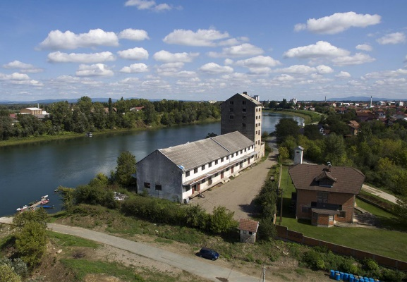
Project title | Brownfield project - Reconstruction and adaptation of the existing facility of the Agricultural Cooperative Gradiška, for the construction of hospitality and accommodation facilities
Sector | Hospitality industry, tourism
Location | Ulica Savska bb, Gradiška
Location description | The facility is located on the river bank of the Sava River, 1 km away from the border crossing from BiH to Croatia, 3 km away from the Banja Luka – Gradiška Highway, and 5 km away from the Belgrade – Zagreb Highway.
Company description | The subject of the investment is a brownfield site which is 100% owned by the Agricultural Cooperative "GRADIŠKA" , and the facility was in the function of drying grain.  The City of Gradiška offers brownfield sites as potential locations for successful investment and business. Proactive and flexible city administration is at the service of potential investors (all necessary permits are issued in record time.)  The city of Gradiška is abundant in tourism potentials, with the Sava River as one of the most important and still not enough used potential.  The benefits provided by the Sava River are numerous. Some of the most important are certainly sport fishing, for which Gradiška has one of the most attractive and best fishing trails in the Republic of Srpska. For many years, the Republic competition in sport fishing has been organized on this trail. For fishing enthusiasts, there is certainly a Sports Fishing Association "Amur" in the city, which can provide detailed information and conditions about sport fishing in Gradiška.  In addition to sport fishing, there are also opportunities for recreational kayaking, where we should definitely mention the Kayak Canoe Club "Sava", which actively works with the youth of Gradiška, and organizes the International Kayak Regatta. The fact that the Sava River is navigable throughout all its length makes preconditions for local economic development, as well as for exploiting the natural potential of the Sava River in the direction of developing nautical tourism.
Project status | - Concept  - The process of finding a strategic partner is in progress.
Project description | Storage space ideal for water transport, environment suitable for hospitality industry and tourism.  The aim of the project is use of the existing facility of the Agricultural Cooperative Gradiška, according to the investor’s needs and requirements.
Estimated total investment cost | The total investment cost will be determined depending on the investor’s needs and requirements.
Inputs provided by local partner | Value |  | Description
Existing facility with surrounding land is available. Surface area of the facility: 1,064 m²; year of construction: 1960.
Construction type: small brick.
Available utility infrastructure: water supply, electric power, sanitation network, lighting; the facility owns its own boiler room.
The necessary permits for construction are issued by the District Commercial Court in Banja Luka. The Urban Development Consent for Works and Construction Permit is issued by the City of Gradiška.
The facility has to be reconstructed and adapted.
Inputs required from foreign partner |  | Value | Description
 |  |  | Investing in the tourist potentials of the Sava River and the City of Gradiška, creating new jobs for professional staff from the area of the city of Gradiška.
Form of cooperation with foreign partner |  | Financial | Technical
 | Concession or sale |  | Management expertise
Supporting information available | For additional information about this project, please contact either by e-mail:  info@e-ventexpo.com or phone number: +387 61 162 591

