**ADVANTAGES OF INVESTMENT IN**

**VINKOVCI**

**ABOUT THA LOCAL COMMUNITY**

**GENERAL INFORMATION**

Town Vinkovci

County: Vukovar-Srijem

Area: 102,805 ha (60,623 ha of fields)

Population (2011): 35,312

Climate: mild continental

Unemployment rate (2021): 4,6 % VSC average in relationship Croatia

Average gross salary (2018): 589,00 EUR (64,5% of Croatian average)

GDP per capita VSŽ (2018): 6,589 EUR (58,5% of Croatian average)

*Picture 1. Position of town Vinkovci in EU, Croatia and Vukovar-Srijem County*



*Source: Town Vinkovci*

Vinkovci has a favorable geo traffic position in the vicinity of Pan-European Corridor X and VC, road and rail corridors that connect Western Europe with Middle East, as well as Central Europe with The Adriatic Sea.

There is a 30km distance to Osijek airport and 20km distance to Vukovar port and Pan-European corridor VII which represent the most important inland Danube waterway from Germany to The Black Sea.

*Picture 2. Position of Vinkovci on main traffic routes*



*Source: Town Vinkovci*

The area of Vinkovci is **rich with cultural, archeological and historical attractions**. Due to its favorable geographical position, many different cultures influenced the area and left material traces, such as archeological sites which prove as evidence of continuously inhabited area for 8,300 years, therefore Vinkovci is the **oldest settlement in Europe**.

Town tourism is based on the use of natural resources (watercourses, forests, protected areas, agricultural lowland area), rich archeological sites and cultural heritage. There are thousands of archeological sites in the town area. Also, the town is proud of the fact that it is a birthplace of two Roman emperors, Valentinian and Valens. As a cultural offer of the town¸ there are many **events** that take place in authentic locations: Carnival horse riding, Winter Šokci Talks, Vinkovci carnival, DORF (festival of documentary film), Puppeteer spring in Vinkovci, Health fair, Seminar on creating traditional hairstyles, Actor festival and Roman days.

**BASIC ECONOMIC DATA**

Town Vinkovci has a significant part in County indicators in the way that there are over 32,08% entrepreneurs who employ over 41,83% of employed persons, and realize 26,17% of total County profit.

In the summary, you will notice the relevant sizes of all existing business entities for 2019. Amounts in Kn:

|  |  |  |  |  |
| --- | --- | --- | --- | --- |
| ***entrepreneurs 693*** | MIKRO | SMALL | MEDIUM | LARGE |
| ***Share capital*** | 68.849.840,00 | 163.834.516,00 | 513.752.757,00 | 293.185.640,00 |
| ***Revenues*** | 1.295.998.816,00 | 1.371.313.254,00 | 1.223.874.022,00 | 1.077.296.261,00 |
| ***Employees*** | 2.493 | 1.848 | 1.913 | 2.117 |
| ***Assets*** | 1.328.587.821,00 | 1.564.959.175,00 | 793.189.087,00 | 978.067.337,00 |
| ***Money*** | 76.569.244,00 | 74.493.665,00 | 80.949.692,00 | 22.247.710,00 |
| ***Net profit*** | -14.275.022,00 | 46.717.662,00 | 208.860.256,00 | 35.638.704,00 |
| ***Investments*** | 69.468.204,00 | 36.446.247,00 | 31.563.286,00 | 66.482.164,00 |
| ***Export*** | 262.560.326,00 | 177.416.784,00 | 120.732.119,00 | 246.367.752,00 |

Table 1: Summary of relevant comparative quantities for 2019.

The most important economic sectors in Vinkovci are wood processing and food sectors.

Vinkovci is traditionally crafts town with the total of 547 registered craftspeople.

Total number of entrepreneurs 693.

THE CITY OF VINKOVCI is the center of education in Vukovar-Srijem County.

Following those:

EDUCATIONAL INSTITUTIONS 7 primary schools, 8 secondary and 2 faculty educational institutions

**Table 2. High schools by type of program and students 2019/2020 in Vinkovci**

|  |  |  |
| --- | --- | --- |
| **Schools** | **Number of students** | |
| **2019./2020.** | **%** |
| **Gymnasiums** | **875** | **24,2** |
| **Technical and related schools** | **2005** | **55,5** |
| **Art high schools** | **37** | **1,04** |
| **Industrial and craft schools** | **666** | **18,4** |
| **Special high schools** | **28** | **0,74** |
| **TOTAL** | **3611** |  |

**Source DSZ**

**FACULTY INSTITUTIONS**

**Professional study Wood Technology, Faculty of Forestry and Wood Technology, University of Zagreb.**

On October 5, 2020, the Vinkovci Music School hosted a formal reception for the first generation of students at the undergraduate professional study Wood Technology at the Faculty of Forestry and Wood Technology, University of Zagreb, which will take place from the academic year 2020/2021. performed in Vinkovci. The study lasts 3 years or 6 semesters, and it earns 180 ECTS credits. Students enroll in 27 compulsory courses, final thesis, and from the offer of electives, two elective courses in the 5th and 6th semester. The academic title upon completion of the study will be: Professional bachelor (baccalaureus / baccalaurea) engineer of wood technology.

**Undergraduate full-time professional study of computer science Vinkovci.**

In the next academic year, 2021/2022, the Faculty of Electrical Engineering, Computing and Information Technologies Osijek (FERIT) will begin training students, through a dislocated undergraduate full-time professional study of computer science in Vinkovci. The professional study will last 6 semesters, and students will gain 180 ECTS credits upon completion. The acquired title will be a professional bachelor's degree in computer science.

**SUPPORT OF THE CITY OF VINKOVAC FOR ENTREPRENEURS**

Creating an environment for accelerated economic development is one of the most important priorities of the City of Vinkovci. Therefore, numerous projects have been launched aimed at building business infrastructure (incubators, business zones, logistics center, etc.).

In cooperation with the city's supporting entrepreneurial institutions: the Vinkovci City Development and Investment Agency, the Vinkovci Technology Park with the new Vinkovci Business Incubator, and ultimately through the work of the City Administration, entrepreneurs are provided with assistance and support in business development and investment, job creation and increase. competitiveness of entrepreneurs.

The City of Vinkovci annually allocates about 2 mil. HRK grants to entrepreneurs operating in the Vinkovci area. The purpose of the program is to create a more favorable entrepreneurial environment for the activities of entrepreneurs and attract investors with the aim of encouraging the overall economic and social development in the city of Vinkovci. The program to encourage entrepreneurship in the city of Vinkovci includes the following support measures:

MEASURE 1 - Investment in technology and human resources

MEASURE 2 - New entrepreneurs

MEASURE 3 - Subsidy for connection to municipal waterworks of existing entrepreneurs

MEASURE 4 - Interest subsidy on loans and credits for entrepreneurs

MEASURE 5 - Promotion of the economy

MEASURE 6 - Entrepreneurship incubator

MEASURE 7 - Assistance to entrepreneurs with difficulties in business due to the coronavirus virus of the Program to encourage agriculture in the city of Vinkovci for 2020 - 2021 includes the following support measures:

MEASURE 1 - Investments in the fruit sector, vegetables and floriculture

MEASURE 2 - Investment in the livestock and poultry sector

MEASURE 3 - Organic production in agriculture

MEASURE 4 - Beekeeping production

MEASURE 5 - Mushroom production

MEASURE 6 - Beginners In addition to grants by the decision of the City Council of Vinkovci entrepreneurs engaged in production and service activities is the compensation of the communal contribution from the maximum 50.00 kn / m³ to 1.00 kn / m³ in the entire city of Vinkovci.

**AREAS SUITABLE FOR INVESTMENTS**

1. **ENTREPRENEURIAL ZONE JOŠINE**

It is situated in the south-east part of Vinkovci, its location is excellent due to the vicinity of important roads: Lipovac-Zagreb and Lipovac-Beograd highway.

* Zone size 75,165 m²
* Size of available land 54,268 m²
* Land use Production and service
* Land selling price based on production and

service investment plan, and the number

of new workplaces 2,00 to 10.67 EUR / m²

* Local rates for all businesses 0,13 EUR / m³
* Exemption from paying local rates to 97%
* Utility equipment: gas, electricity, water, drainage
* The level of activation is 74%
* Only one free parcel of land 1.594 m²
* By selling parcels, entrepreneurs are given supports through lower prices of building land in value of approximately 5,5 million kuna (estimated).

*Picture 3. Entrepreneurial zone Jošine sketch*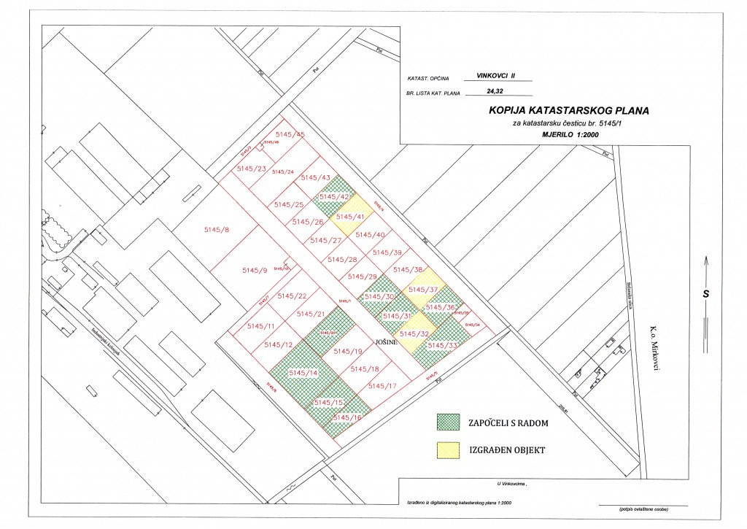

*Source: Town Vinkovci*

1. **INDUSTRIAL ZONE ZALUŽJE**

Location - south-east part of the town by the state road Vinkovci – Županja, its location is excellent due to the vicinity of important roads: Lipovac-Zagreb and Lipovac-Beograd highway.

Zone size 38,42 ha

Entrepreneurs intended 29.32 ha

The level of activation 97,88 %

Planned extension zone 160 ha

By extending this zone, entrepreneurs´ supports would be provided through lower prices of building land in value of 1.733,333 EUR.

*Picture 4. Entrepreneurial zone Zalužje*

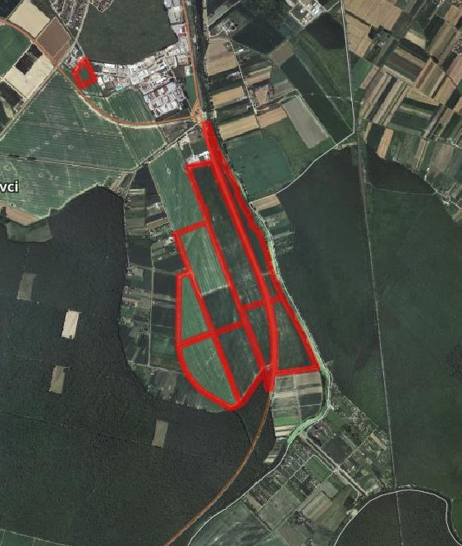

*Source: Town Vinkovci*

**ENTREPRENEURIAL SUPPORTING INSTITUTIONS**

1. **INVESTMENT AND DEVELOPMENT AGENCY OF THE CITY OF VINKOVCI – VIA Ltd.**

ENTREPRENEUR INFORMATION CENTER is active within the agency and it was initiated by the support of Ministry of Economy, Entrepreneurship and Crafts. It provides services to entrepreneurs of Vinkovci area and other interested investors:

• information and counseling upon starting business,

• business planning, business plan design service and investment studies,

• information, counseling and help with preparation and implementation of planned investments and EU projects.

Despite helping entrepreneurs, The Agency tries to enhance entrepreneurial environment through numerous projects it develops and applies in partnership with the town Vinkovci and key local stakeholders. The Agency´s aim is to create conditions for entrepreneurial growth through next groups of activities:

* Developing entrepreneurial climate
* Developing entrepreneurial infrastructure
* Entrepreneurship promotion
* Support in entrepreneurial projects development
* Education for entrepreneurship

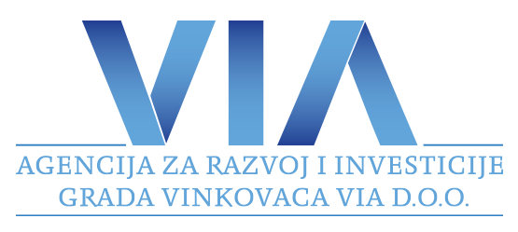

[***danijela.slipcevic@viavinkovci.hr***](mailto:danijela.slipcevic@viavinkovci.hr)

[***www.viavinkovci.hr***](http://www.viavinkovci.hr)

**II TECHNOLOGY PARK VINKOVCI Ltd.**

Technology Park Vinkovci doo is a company founded with the aim of affirming the entrepreneurial spirit in Vinkovci, but also the entire Vukovar-Srijem County.

Newly founded business entities in Technological park have preferential tariffs of rent during the time of business entity incubation for 5 years, free speed internet, the use of conference rooms, preliminary contract on the address when opening a company:

**Business lease in Technological park Vinkovci**

First year of lease 0% of the market lease rate 6,00 EUR/m²

Second year of lease 25% of the market lease rate 6,00 EUR/m²

Third year of lease 50% of the market lease rate 6,00 EUR/m²

Fourth year of lease 75% of the market lease rate 6,00 EUR/m²

Fifth year of lease 100% of the market lease rate 6,00 EUR/m²

**Annual subvention per entrepreneur in the first year is approximately 2,200 EUR for the office rent of 30 m².**

**Overhead expenses**

For five years of rent the price of overhead expenses is 2,00 EUR/m²

**The development of new services:**

Virtual office, mentorship, transfer of knowledge and technology, support to establishing quality systems, attaining attests and certificates, enhancing organizations and management, education, fair appearance, business rules on foreign markets etc.

picture 5. Technological park Vinkovci Ltd.

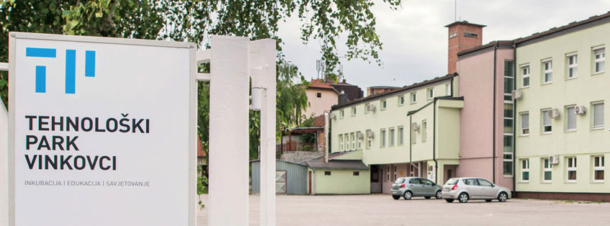*Source:* [*http://tp-vk.hr/*](http://tp-vk.hr/)

**III BUSINESS INCUBATOR VINKOVCI (implemented 2020)**

The aim of the project is to improve the business infrastructure and business of small and medium-sized enterprises with the aim of facilitating its growth and development and creating opportunities for job creation in the City of Vinkovci and Vukovar-Srijem County.

Location 5678 cadastral parcel Vinkovci II, total area 5,214 m²

Total gross area of the object: 2,147 m²

* 5 production areas 759 m²
* 14 business offices 1,388 m²
* administrative part of the building 97 m²
* conference room 100 m²
* multi-purpose room 100 m²

Surface of access roads and parking lots 3,178 m²

Green surface 1,122 m²

Existing object is completely reconstructed, and a new part of the object is built**.**

Picture 6. Business incubator Vinkovci [www.inkubator-vinkovci.eu](http://www.inkubator-vinkovci.eu)

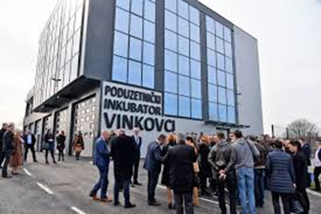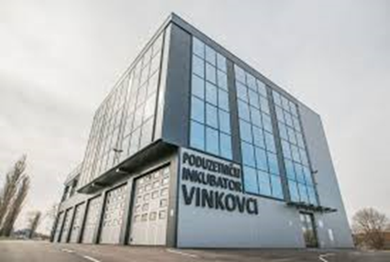

*Source: Town Vinkovci*

STRATEGIC PROJECTS OF THE TOWN VINKOVCI

**Table 4.** Selected development projects of the City of Vinkovci

|  |  |  |
| --- | --- | --- |
| **NAZIV PROJEKTA**  **PROJECT NAME** | **KRATKI OPIS PROJEKTA**  **SHORT DESCRIPTION OF THE PROJECT** | **VRIJEDNOST PROJEKTA u EUR PROJECT VALUE in EUR** |
| City Library and reading room Vinkovci  In the process | The project plans to build a 4,482 m2 city library and reading room building. | 5.500.000 |
| Museum with interpretation center  In plan | The project plans to build a 7.900 m2 building, which will include a museum gallery, a souvenir shop and a planetarium, for the presentation of a rare valuable luxury silverware dating site dating from the end of the 4th century found in the center of Vinkovci. | 9.160.000 |
| Reconstruction and presentation of the early Christian church of St. Elijah in Meraj  In plan | The project is planning to reconstruct the Gothic church in Meraj in the gallery-space area in order to strengthen the tourist infrastructure and offer Vinkovci as the oldest city in Europe. | 1.225.600 |
| Development of broadband access in the Vinkovci area  In plan | The project contributes to the achievement of the national strategic goals set by the Strategy for Development of Broadband Access in the Republic of Croatia in the period 2012-2015 and the Digital Agenda for Europe in the period up to 2020, especially in the aspect of ensuring the availability of fast and ultra-fast broadband access. | 12.500.000 |
| Construction of a market  In plan | The project is planning to build a new semi-open market for marketing and marketing of local agricultural products - a combination of rural and urban. | 2.400.000 |
| Construction of overpasses via the Zagreb - Tovarnik railway line  In the process | The project planned the construction of overpasses via the Zagreb - Tovarnik railway line, which would connect the Borinci settlement with the better road infrastructure with the center of the town of Vinkovci. The project encourages intermodal traffic, as it would improve the linkage of road freight with railways, thereby disrupting part of the city's traffic. | 10.600.000 |

*Source: Town Vinkovci*

**Selected projects in project realization**

**TLC - Transport Logistics Center**

The project "Transport and Logistics Center of Vukovar-Srijem County" is, due to its importance and possible significant impact on economic development, job creation, investment attraction and general raising of living standards, defined as a strategic project of Vukovar-Srijem County.

The project idea is based on the use of the geostrategic position of Vukovar - Srijem County, which is a significant comparative advantage compared to neighboring counties and the region of Eastern Europe as a whole. The position of Vukovar - Srijem County is the basis for the intensive development of the logistics - transport component, given that significant European traffic routes (river, railway and road) intersect in the county.

 For the geo-traffic position of the Transport and Logistics Center in Vinkovci, the most important railway traffic route is Corridor X: (Ljubljana, Dobova) - Savski Marof - Zagreb - Novska - Strizivojna / Vrpolje - Vinkovci - Tovarnik - (Sid, Belgrade). The location of the Transport and Logistics Center of Vukovar-Srijem County is at the former freight station of the city of Vinkovci, which is not in function.

Project-technical documentation is currently being prepared in order to proceed with the construction of the necessary infrastructure on the 500,000 m2 zone, which is planned for 2022 and 2023. The project plans to build a total of 1,400 meters of industrial tracks.

The Transport and Logistics Center will be a hub for the wider region in this part of Eastern Europe, in which private businesses will perform transport, logistics and distribution of goods (in national and international transit), on a commercial basis (distribution centers, wholesale, warehousing and transport, logistics and service centers, etc.).

Other economic activities of interest to TLC users (production, finishing, handling and storage of products) are also planned, in accordance with the needs of the user and its basic purpose. This project is in the function of attracting investors by highlighting the competitive advantages of the area, but also the opportunities for the construction of logistics, distribution and production facilities with a significant reduction in the total initial costs of construction and start-up.

The project of the Transport and Logistics Center of Vukovar-Srijem County has a regional investment in terms of its size, and after the completion of the entire investment, it will also have national significance.

The project is intended for the development of transport and logistics activities and the return of the importance of the City of Vinkovci and Vukovar - Srijem County as an important transport hub.

**Project - Hungarian School**

Educational and Development Center Vinkovci

The duration of the project is from May 15, 2020 to May 15, 2023, and after the preparation of project-technical documentation will apply for funds for the reconstruction of the building whose purpose is to accommodate educational and sports-recreational institutions and associations to contribute to improving the educational structure the city of Vinkovci and Vukovar-Srijem County, and the development of an economy based on knowledge and innovation.

First of all, the building will have the space of the Josip Runjanin Music School, the College of Informatics with an innovation and development center, which is in the process of being established in cooperation with the College of Information Technology Zagreb, and the Study of Wood Technology.

**Investment areas of the City of Vinkovci according to the resources of the area.**

FORESTRY - Slavonia is rich in forests and the famous Slavonian oak, which enables the production, processing of wood and production of wood products.

**FOREST ADMINISTRATION VINKOVCI BRANCH**

The Vinkovci branch consists of 12 forestry that take care of and maintain them.

**Economic potentials:**

Significant companies operating in the area of ​​Vinkovci.

**SPAČVA D.D.**

Spačva is today a successful, stable and promising company. The leading wood industry in Croatia in terms of size, organization, management approach and business transparency. It currently employs 850 workers, making it one of the largest employers in the wood industry, Vukovar-Srijem County and Vinkovci. It produces exclusively final products, mostly in oak, which it primarily exports. The products can be purchased in 30 countries around the world, and the most important markets are France, Italy and Germany. The results they have achieved so far are a good basis for achieving the European level of competitiveness.

PRODUCTION OF TILES AND BRICKS

**Nexe group / DILJ d.o.o.**

DILJ d.o.o. Vinkovci was founded in 1922.

It is engaged in the production of tiles, and in the Slavonia IGM Factory in Našice the production of bricks.

It is a company of tradition and continuity, customer-oriented, which continuously strives to meet customer expectations with regard to the quality and price of its products.

Construction company

**SOKOL d.o.o.**

It is an established contractor of construction and assembly works of civil engineering and building construction with many years of experience in the construction and maintenance of energy and telecommunications lines and networks, pipelines and installations and buildings for various purposes.

**CESTORAD D.D.**

After the development and experience gained over 20 years in the field of civil engineering, and especially road construction, since 1990 the company operates under the name Cestorad d.d. as a joint stock company that is 100% owned by employees.

Today it is a modernly organized company with about 150 employees, mostly highly educated and highly qualified staff. CESTORAD D.D. has the most modern mechanization for road construction, whether it is preparatory earthworks or final asphalting works, and a completely new microprocessor-controlled asphalt base of large capacity.

Operating on the market of eastern Croatia, especially the Vukovar-Srijem County, and neighboring Bosnia and Herzegovina, the company CESTORAD D.D. has gained a great reputation, but also the obligation to continue to prove itself as a leading company in civil engineering in the area.

**WATMONT D.O.O.**

The company is 100% privately owned.

Through hard work, commitment and investment, it has developed into a respectable business entity in the area of ​​the city of Vinkovci, which always employs over 100 employees of various professions related to the performance of construction and craft works.

The trend of growth and constant employment of new workers has been recorded for the last 10 years.

It is geographically covered regionally, and bases its business on the domestic market. One of the essential areas that helps create the long-term competitive advantage of this serious company is human resource management. The ability to respond to competitive market conditions is the result of the fact that there are enough people in the company structure with the appropriate knowledge, skills and motivation, therefore, workers play a significant role in the conception and application and development of business goals that affect the financial results and overall reputation and efficiency of the company. The company Watmont d.o.o. has a large number of special machines and equipment that enables fast and quality execution of projects in all areas of construction.

Construction and craft work performed by Watmont d.o.o. include:

• Construction works • Electrical installation works • Energy renovation • Facade works • Painting works • Plasterboard works • Carpentry works • Locksmith works • Carpentry works. In addition to performing construction and craft works,

Watmont d.o.o. also has its own PVC production.

**RASPON d.o.o.**

for construction, trade and services Vinkovci, is a contractor of civil engineering and building construction, with many years of experience in the construction of residential, public and commercial buildings.

The Ministry of Environmental Protection, Physical Planning and Construction issued on 31.03.2009. year consent for the execution of works of group F construction.

The company Raspon d.o.o. currently employs 50 employees of various professions with certain qualifications, medical certificates and certificates of competency to work in a safe manner in the field of occupational safety.

The structure of employees, their equipment and all the necessary supporting documentation ensures the quality construction of these buildings. The company Raspon d.o.o. owns a vehicle fleet, the necessary mechanization and tools that have all the necessary attestation documentation and testing certificates in the field of occupational safety.

In addition to the construction business, we sell and service all types of tires, which includes a well-equipped workshop for all types of vehicles.

**AKSION d.o.o.**

In our many years of practice, we have performed work on a number of family houses and business facilities. Since 1996, we have been engaged in the renovation of family houses in our counties: • Sisak - Moslavina • Vukovar - Srijem • Šibenik - Knin

**BODAT d.o.o**.

The company Bodat doo was founded in 1990. The original activity was the sale of construction materials and firewood. Over time, we have expanded our business and today the company is engaged in the sale and distribution of construction materials, and the execution of all types of construction work, as well as the transport of bulk cargo and construction materials. The building material warehouse offers complete construction material for the construction of all types of buildings. In addition to the warehouse in Vinkovci, we also have a warehouse for construction materials in Županja, JJ Strossmayera bb on over 11,000 m2.

**AMM d.o.o.**

AMM was founded in 1993 for civil engineering activities and has been privately owned ever since. Our vision is to be an unavoidable partner in the field of activity, to offer top service to our clients at competitive prices and from the first day we are guided by that thought and after 20 years of work where we completed all projects and handed them over to the investor vision. There were really a lot of projects, over 80.

It all started with works on the telecommunications network of the Croatian telecom operator in the area of ​​Eastern Slavonia, where the majority of our projects were carried out.

In those first two years, we completed 100 km of telecommunications network.

Later, the investor's activity was transferred to gas, and in the following years we worked on the construction of gas networks, and subsequently water and sewage. In the past 20 years, we have built a total of 500 km of infrastructure networks in all materials, dimensions and purposes with accompanying facilities with a total value of our services over 25 million euros.

**SUHOMONT d.o.o.**

In our offer we offer services of engineering solutions and execution of works in the field of electrical engineering, mechanical engineering and construction.

**Contact:**

**Town Vinkovci**

Bana Jelačića 1, 32100 Vinkovci

Contact person: Hrvoje Niče

+385 32 337 200

hrvoje.nice@vinkovci.hr

www.vinkovci.hr

**INVESTMENT AND DEVELOPMENT AGENCY**

**OF THE CITY OF VINKOVCI – VIA Ltd.**

Glagoljaška 4, 32100 Vinkovci

Contact person: Danijela Slipčević

+385 32 340 030

[danijela.slipcevic@viavinkovci.hr](mailto:danijela.slipcevic@viavinkovci.hr)

[www.viavinkovci.hr](http://www.viavinkovci.hr)