EVENT & EXPO INVESTMENT PROJECT PROFILE

Stupska bb, 71000 Sarajevo / Tel. +387 61 162 592 +387 62 324 495/ www.e
-
ventexpo.com /

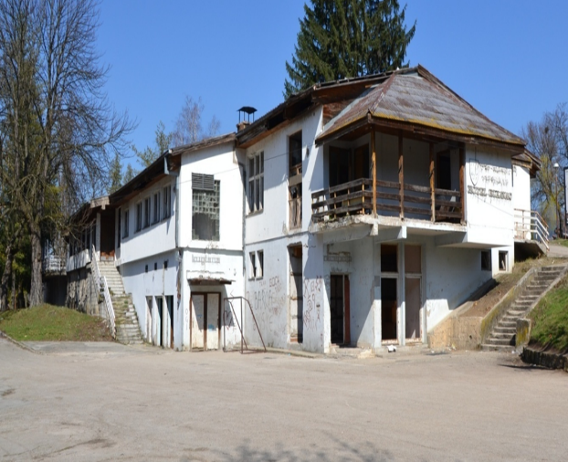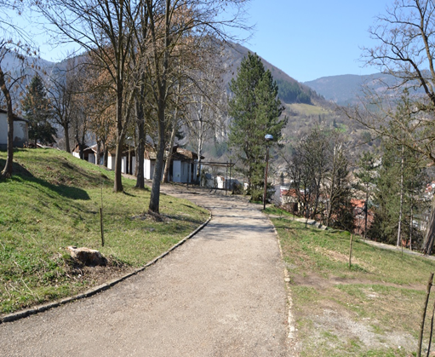
Project title | Brownfield project. Tourist complex Bikavac
Sector | Tourism
Location | Bikavac, Visegrad, Republic of Srpska, Bosnia and Herzegovina
Location description | It is located in eastern Bosnia and Herzegovina. It is connected to Sarajevo and traffic corridors in BiH and Serbia by a highway.  Distance from the main centers in the country and abroad:  Tourist facilities on the mountain Jahorina, BiH 123 km  Tourist facilities on the mountain Maglic 72 km.  Sarajevo Airport 132 km  Tourist place Mokra Gora in Serbia 20 km  Tourist facilities on the mountain Tara in Serbia 42 km  Tourist facilities on the mountain Zlatibor, Serbia 75 km.
Company description | The Municipality of Visegrad offers a brownfield location as a potential location for successful investment and business. The location is 100% owned by the Municipality of Visegrad. The total land area is 12,551 m2, and the facilities are 2,493 m2. The location is equipped with a devastated motel building with 11 apartment-type bungalows built in 1980, a type of construction - brick , low voltage electricity network, water and sewage network and a network of road and pedestrian communications. The location is in the inner city zone at a distance of about 300 m away from the town square, the Mehmed-pasha Sokolovic bridge, the tourist narrow-gauge railway Visegrad-Mokra Gora and the tourist-educational complex Andricgrad.  Visegrad is an attractive tourist destination with a rich and diverse cultural, historical and natural heritage. The most important cultural and historical monuments are the Mehmed-pasha Sokolovic Bridge (inscribed on the UNESCO World Cultural Heritage List), the Dobrun Monastery from the 14th century and the museum-tourist railway of the narrow gauge Visegrad-Mokra Gora. In the category of natural heritage, the following stand out: the picturesque canyon of the river Drina, the springs of thermal water in the Visegrad Spa, endemic and relict plant and animal species (Pancic spruce, fern Vilina vlas, sprout). A special attraction is the Andricgrad complex with its facilities. The interest of tourists to stay in Visegrad is constantly growing. In 2020, there were 32,578 overnight stays.
Project status | Concept  The process of finding a strategic investment partner is ongoing.
Project description | The facility should be reconstructed and adapted to provide accommodation and catering and tourism services in accordance with the needs of investors. A proactive municipal administration is available to investors for the necessary permits.
Estimated total investment cost | The total investment costs will be determined depending on the needs and requirements of the investor.
Inputs provided by local partner | Value |  | Description
 | EUR |  | There is an existing motel and 11 bungalows with surrounding land of 12,551 m2 for rent or sale.  The decision for registration of a business entity issues the District Court in East Sarajevo. The urban consent for works and building permits issues the Municipality of Visegrad.
Inputs required from foreign partner |  | Value | Description
 | EUR |  | Reconstruction, adaptation and equipping of the facility
Form of cooperation with foreign partner |  | Financial | Technical
 |  |  | Lease or sale

Supporting information available | For additional information about this project, please contact either by e-mail:  info@e-ventexpo.com or phone number: +387 61 162 591

