EVENT & EXPO INVESTMENT PROJECT PROFILE

Stupska bb, 71000 Sarajevo / Tel. +387 61 162 592 +387 62 324 495/ www.e
-
ventexpo.com /

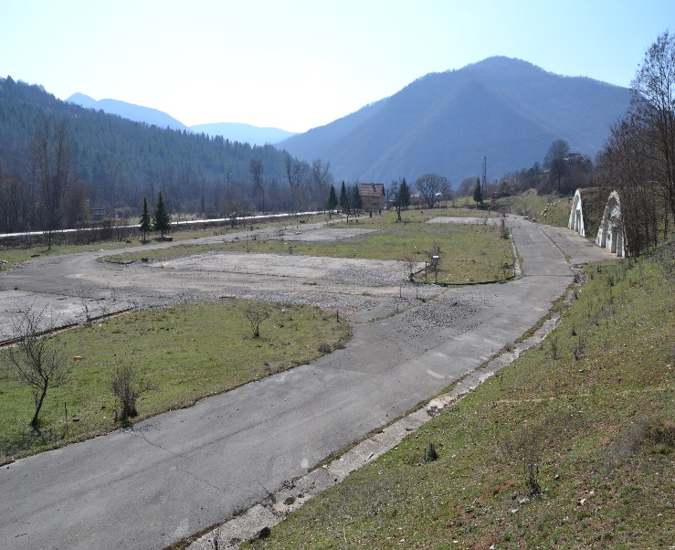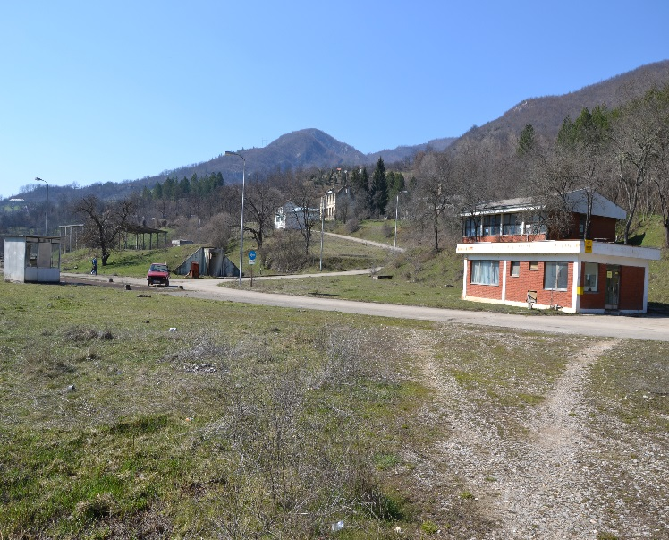
Project title | Brownfield project. Former military complex in Vardište
Sector | Business
Location | Vardiste, Visegrad, Republic of Srpska, Bosnia and Herzegovina
Location description | It is located in eastern Bosnia and Herzegovina. It is connected to Sarajevo and traffic corridors in BiH and Serbia by a highway.  Distance from the main centers in the country and abroad:  Sarajevo International Airport 132 km  Railway station Uzice 70 km  Railway station Priboj 39 km  It is located next to the border with the Republic of Serbia and the border crossing Vardiste. It is positioned 18 km away from the city center of Visegrad and is directly connected to the main road M5 Sarajevo-Uzice. It is located in eastern Bosnia and Herzegovina. It is connected to Sarajevo and traffic corridors in BiH and Serbia by a highway.
Company description | The Municipality of Visegrad offers a brownfield location as a potential location for successful investment and business. The location is 100% owned by the Municipality of Visegrad. The total land area is 19,454m2, and of the facilitiey is 593 m2. The location is equipped with an underground hangar for fuel storage of 593 m2, a terminal, a transformer station with a capacity of 400 KWA, low voltage electricity network, water and sewage network, as well as a network of road communications and handling areas.  The original purpose of the site was a military warehouse for liquid fuels.
Project status | Concept  The process of finding a strategic investment partner is ongoing.
Project description | The facility should be adapted to the needs of investors. A proactive municipal administration is available to the investor to issue the necessary permits.
Estimated total investment cost | The total investment costs will be determined depending on the needs and requirements of the investor
Inputs provided by local partner | Value |  | Description
 | EUR |  | There is an existing facility underground hangar of 593 m2 for rent.  The decision for registration of a business entity issues the District Court in East Sarajevo. The urban consent for works and building permits issues the Municipality of Visegrad.
Inputs required from foreign partner |  | Value | Description
 | EUR |  | Adaptation and equipping of the facility
Form of cooperation with foreign partner |  | Financial | Technical
 |  |  | Lease

Supporting information available | For additional information about this project, please contact either by e-mail:  info@e-ventexpo.com or phone number: +387 61 162 591

