EVENT & EXPO INVESTMENT PROJECT PROFILE

Stupska bb, 71000 Sarajevo / Tel. +387 61 162 592 +387 62 324 495/ www.e
-
ventexpo.com /

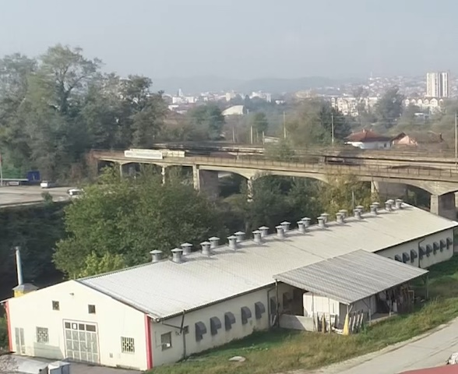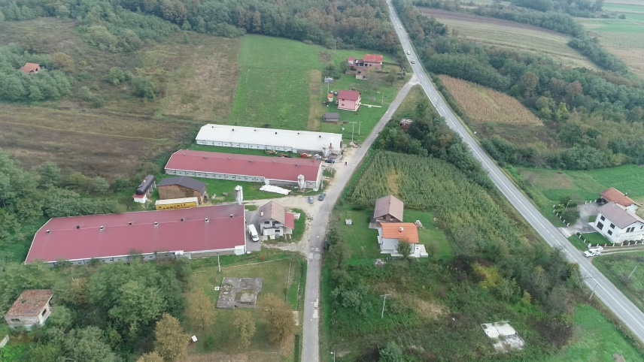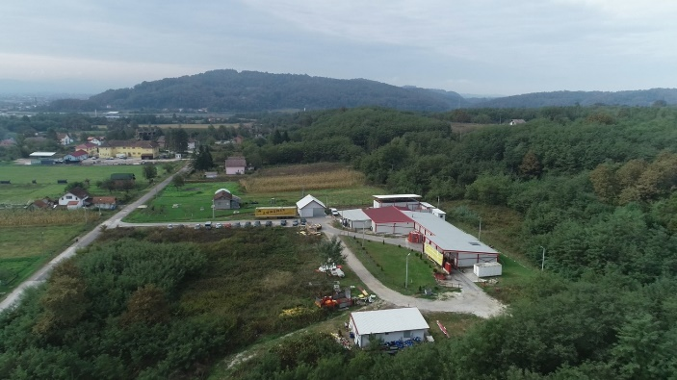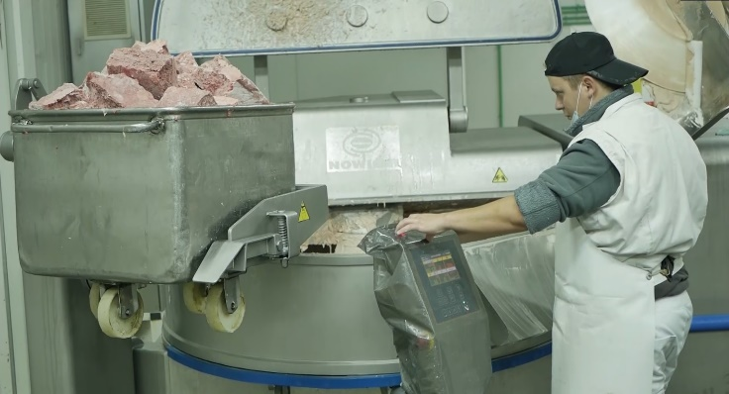

Project title
Sector
Location
Location description

Company description

Project status
Project description

Estimated total investment cost
Inputs provided by local partner | Value |  | Description
Inputs required from foreign partner |  | Value | Description
Form of cooperation with foreign partner |  | Financial | Technical
Project proposed by | Company/Municipality
 | Legal status
 | Address
 | Contact person
 | Telephone
 | Fax
 | E-mail
 | Website
Other project partners | Company/Municipality
 | Legal status
 | Address
 | Contact person
 | Telephone
 | Fax
 | E-mail
 | Website
Supporting information available | For additional information about this project, please contact either by e-mail:  info@e-ventexpo.com or phone number: +387 61 162 591

